**1.Power BI Instalation screnn shot**

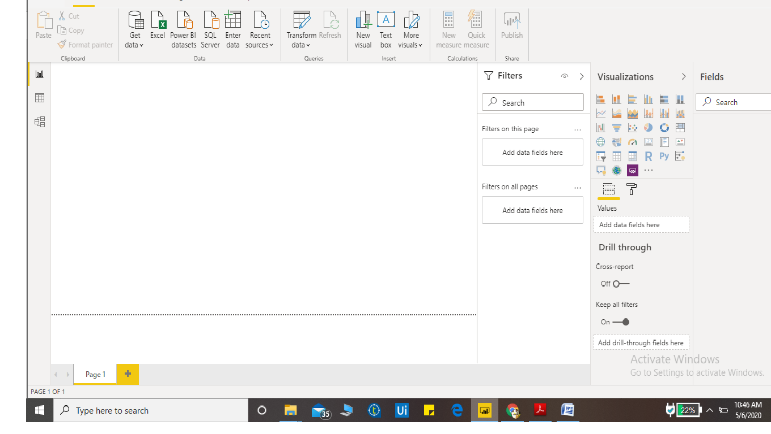

2. **Report View**

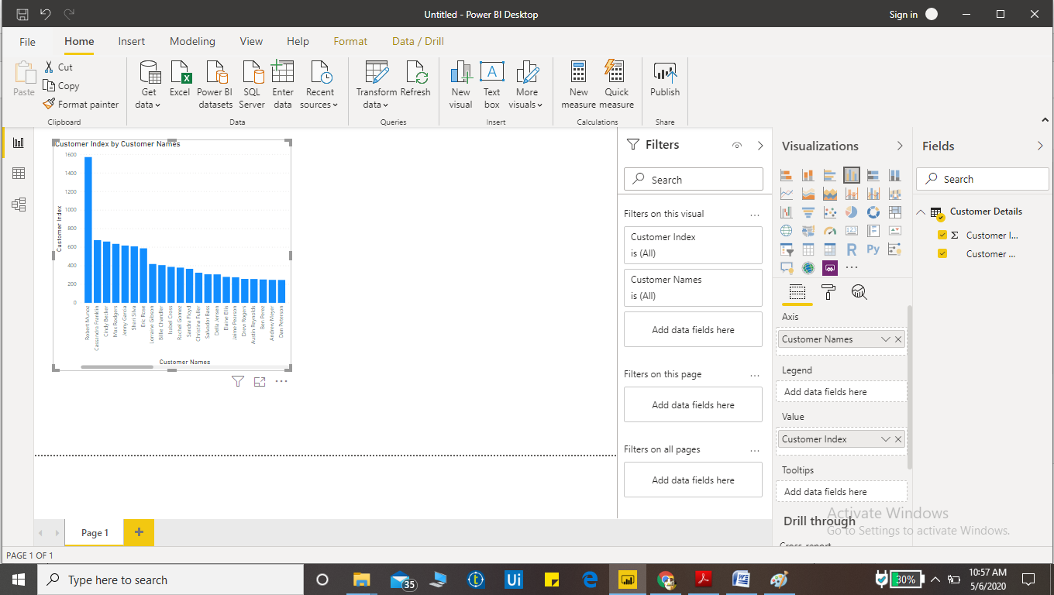

**Data View**

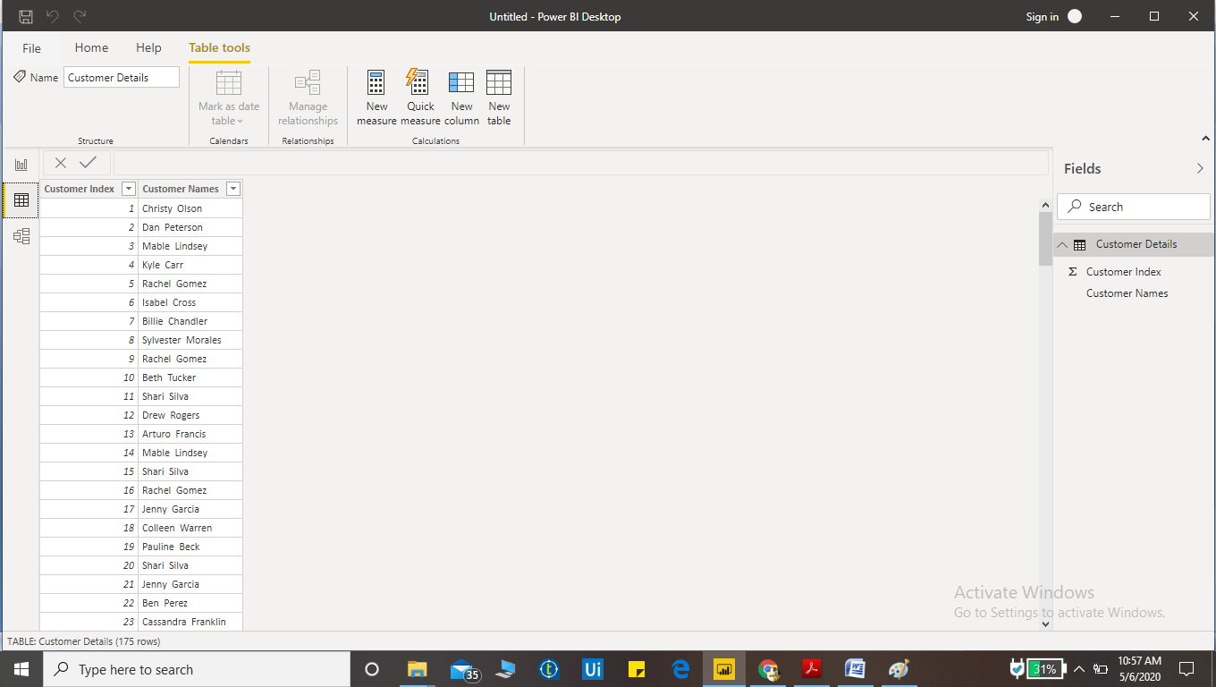

**Model View:**

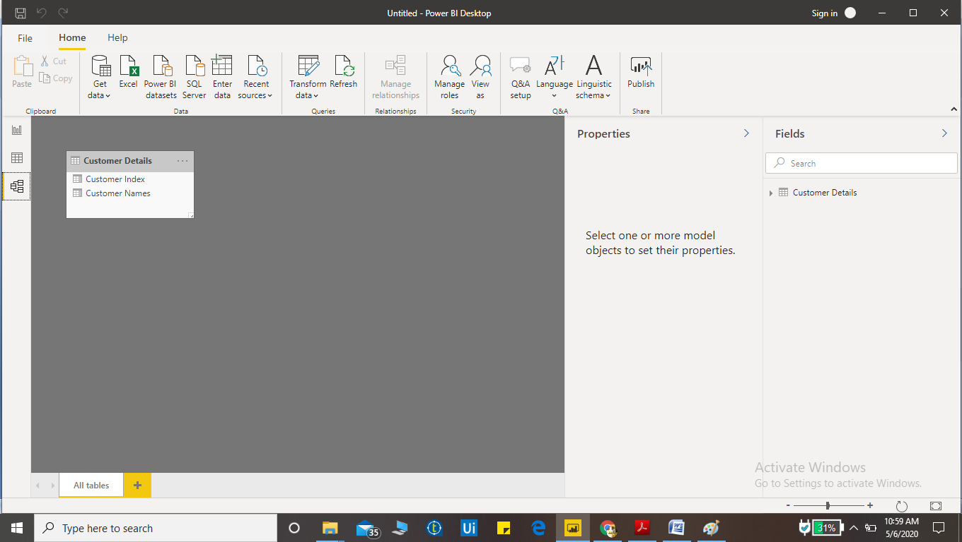

**Power Query Editor :**

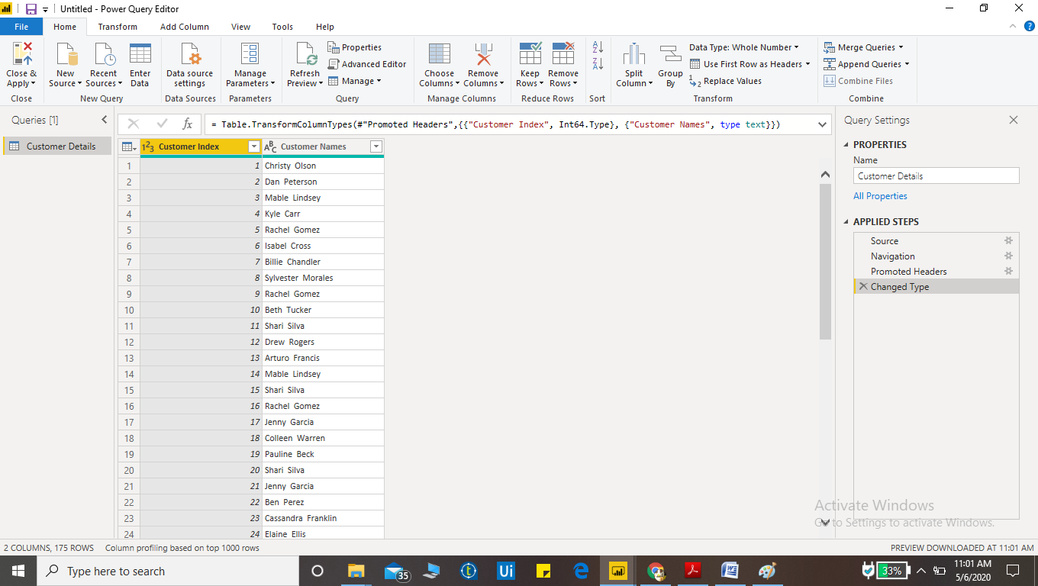

**Advanced Editor:**

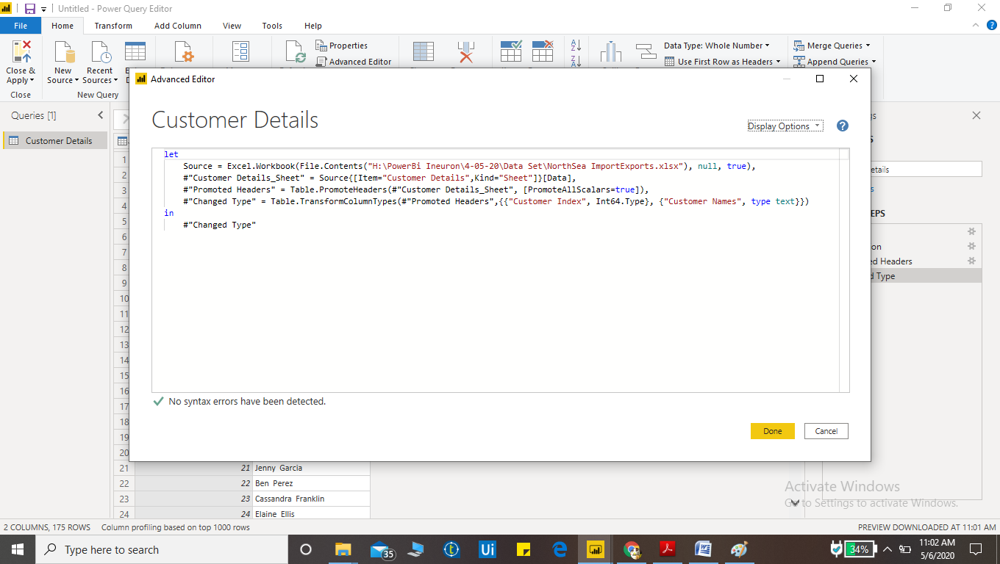

**Power BI Desktop:**

The basic version of Power BI is free. All you have to do is sign up  and enter your business email address, then you will get a message from Microsoft telling you how to start enjoying the benefits of Power BI and its interactive dashboards. The free version comes as a desktop-based app only. You might be surprised, though, at how many essential features the free version includes.

It offers the ability to connect with more than 70 data sources, clean and prepare data with visual tools, analyze and build custom reports with exceptional visualizations and advanced analytics, and easily export to PowerPoint, Excel and CSV.

All of Power BI’s features are mobile-responsive as well, with native apps for iOS, Windows, and Android devices, and you can import data from a wide range of sources, including spreadsheets, email marketing providers, and other streams.  Reports can be embedded into existing apps or websites.

**Cost**: Free

**Power BI Pro:**

With Power BI Pro, users are licensed individually and participate fully in the use of Power BI – both the creation of content and the consumption. All Pro users can connect to hundreds of data sources on-premises and in the cloud, create interactive reports and 360-degree dashboards, share that content with other Pro users, and consume content shared by others.

**Cost:** $9.99 Monthly per UserMonthly price per user

**Power BI Premium:**

With Power BI Premium, you are licensing capacity for your content rather than licensing all users of that content. Content (datasets, dashboards, and reports) is stored in Premium and can then be viewed by as many users as you want, without additional per-user costs. These users can only view content, not create it. Viewing includes looking at dashboards and reports on the web, in our mobile apps, or embedded in your organization’s portals or apps. The creators of content in Premium still need their own Pro licenses.

**Cost:** $4,995 Monthly price per dedicated cloud compute and storage resource with annual subscription